Ownership Certificate
To Whom It May Concern
This is to certify that the following equipment mentioned below are the sole owned by Sudhir Equipment Rental Company

Equipment | Tower Light
Brand / Make | VARADA
Asset ID | 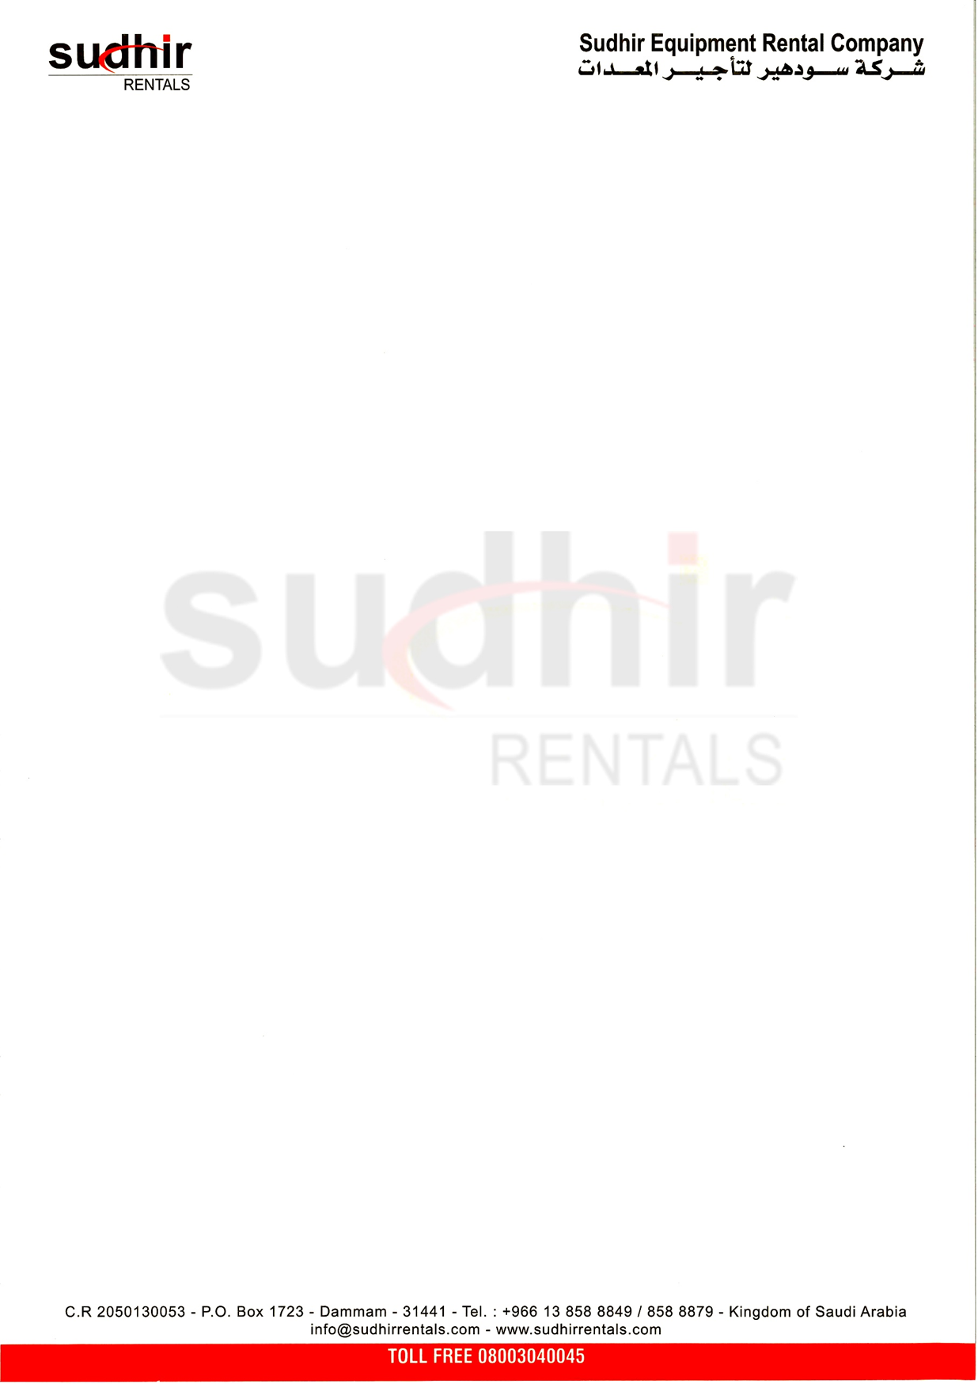  STL-169
Model Number | VTevo K2
Serial Number | PEC00224456
Engine Serial Number | 5329300496
Rating | 1600 W
Year of Manufacturing | 2022

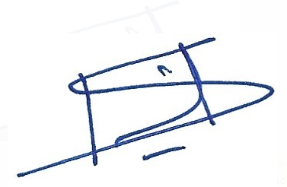
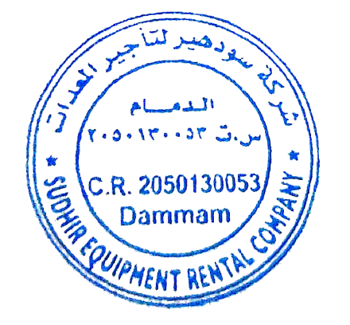
Authorized Signature
Branch Manager
Sudhir Equipment Rental Company
Kingdom of Saudi Arabia

